

Back propagation Task
We’re going to use a neural network with two inputs, two hidden neurons, and two output neurons. Additionally, the hidden and output neurons will include a bias.
Here’s the basic structure:

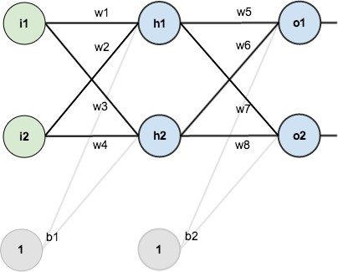

X1 | X2 | Desired-1 | Desired-2
0.05 | 0.10 | 0.01 | 0.99

W1 | W2 | W3 | W4 | W5 | W6 | W7 | W8 | B1 | B2
0.15 | 0.20 | 0.25 | 0.30 | 0.40 | 0.45 | 0.50 | 0.55 | 0.35 | 0.6

The goal of back propagation is to optimize the weights so that the neural network can learn how to correctly map arbitrary inputs to outputs.

- calculate the total net input for h_1 --> 0.3755
- using the logistic function to get the output of h_1 --> 0.5933
- Repeat step-1 and 2 to calculate h-2 --> 0.3925 0.5969
- Repeat this process for the output layer neurons, using the output from the hidden layer neurons as inputs.
- Calculating the Total Error using
- The Backwards Pass
With backpropagation, we want to minimize the error for each output neuron and the network overall by updating each weight in the network to bring the actual output closer to the intended output.

Output Layer
Consider w_5. We want to know how much a change in w_5 affects the total error,
By applying the chain rule
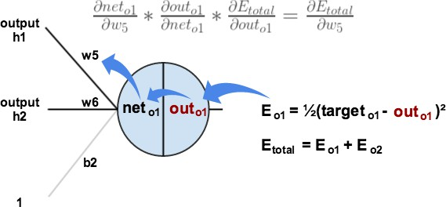
- how much does the total error change with respect to the output?

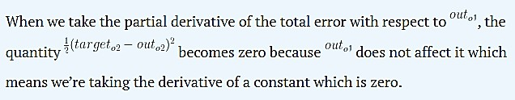

Note
- how much does the output of o_1 change with respect to its total net input?

Note
The partial c of the logistic function is the output multiplied by 1 minus the output

- how much does the total net input of o1 change with respect to w_5?
- Repeat this process to get the new weights w_6, w_7, and w_8:
- ​

Hidden Layer

- calculating new values for w_1, w_2, w_3, and w_4.

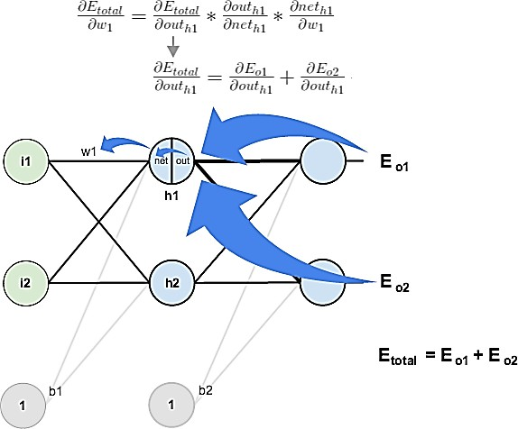

Finally, You’ve updated all of your weights! When you fed forward the 0.05 and
0.1 inputs originally

W1 | W2 | W3 | W4 | W5 | W6 | W7 | W8 | B1 | B2
0.1499 | 0.1999 | 0.249 | 0.299 | 0.399 | 0.499 | 0.50 | 0.55 | 0.349 | 0.599

the error on the network was (0.2975) After this first round of
backpropagation, the total error is now down to(0.2971)I think not seem
like much.
Using the Bp.py Python code adjust the code look like this example to make sure your calculation for first iteration then repeating this process 10,000 times, when you feed forward 0.05 and 0.1, give me your prediction .

